Project Development Phase
Implementation Overview
The development of the Credit Card Approval Prediction system was carried out according to the proposed project design. Data cleaning, preprocessing, categorical encoding, feature selection, model training, and evaluation were performed using a Jupyter Notebook.
The trained machine learning model was saved using Pickle as model.pkl. The saved model was integrated with a Flask web application. The application accepts applicant information through an HTML form, processes the input values, and predicts whether the credit card application is approved or rejected.

Key Modules
Training Notebook – Used for data loading, data cleaning, preprocessing, categorical encoding, feature selection, model training, and model evaluation.
Flask/app.py – Handles web requests, loads the trained model.pkl file, processes applicant input, and performs credit card approval prediction.
templates/index.html – Provides the applicant input form for entering gender, income, employment, education, housing, and other required details.
templates/result.html – Displays the final prediction as Credit Card Approved or Credit Card Rejected.
static/style.css – Provides styling and improves the user interface of the Flask web application.
model.pkl – Stores the trained machine learning classification model used for prediction.

Model Results
Machine learning classification models were trained and evaluated to identify a suitable model for credit card approval prediction. The performance of the models was compared using accuracy and other classification evaluation metrics.

Model | Estimated Accuracy
Logistic Regression | 76.5%
Decision Tree | 74.8%
Random Forest | 80.2%
XGBoost | 81.5%

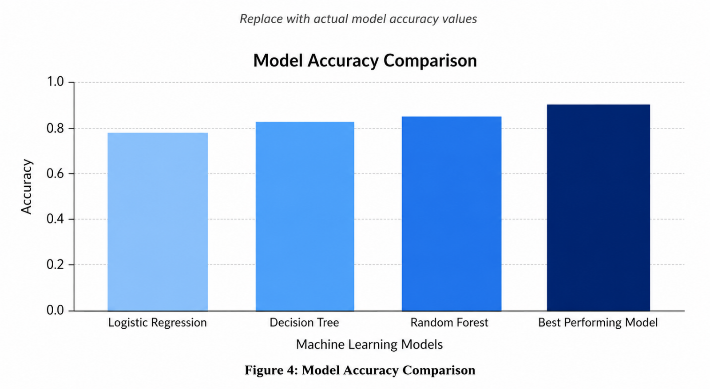
Model Result Description
Based on the model evaluation results, the best-performing machine learning model was selected and saved as model.pkl. The selected model was integrated into the Flask application to predict credit card approval status based on applicant details.

